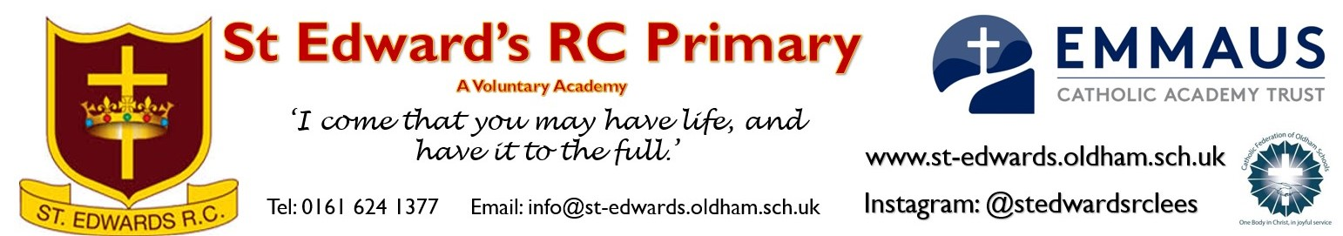
Teacher required for September 2024
Job Type: Education School based, Teacher
Salary Grade: Main Scale (or higher dependent on successful candidate)
Working Pattern: Full Time
Closing date – Thursday 25th April @ 9am
Shortlisting - Thursday 25th April
Interviews – Friday 3rd May 2023

Working Hours: 1.00 FTE
Contract Type: Permanent
Closing date: Thursday 25th April 2024
Interview Date: Friday 3rd May 2024

"Pupils have a strong sense of belonging and pride in their school. They value and respect their peers and the adults who work with them. Staff are committed to St Edward’s, and the school’s strong sense of community arises from its embedded culture of respect for the wellbeing, rights and dignity of all." (Catholic Schools Inspection; November 2023).

The governors at St Edward’s are looking to appoint an excellent, enthusiastic and highly motivated teacher to join the staff of this ambitious; forward-thinking and welcoming Roman Catholic school. Applications are welcome from teachers with a range of experience – the class and year group that will be taught will be dependent on the skills and expertise of a successful candidate. Across school, there are opportunities to plan together and to work closely in partnership with other experienced teachers and to drive change in a subject area of the curriculum. As part of the Emmaus Catholic Academy Trust, there are opportunities to work with and share good practice with colleagues across the academy footprint.

“Emmaus Catholic Academy Trust is committed to safeguarding children and young people. All post holders are subject to appropriate vetting procedures as outlined in Part 3 of DfE, KCSiE 2023, this includes a satisfactory Disclosure and Barring Service Enhanced with barred list information check”.

If you would like to arrange a meeting with the school before you apply you would be very welcome - please contact the office if you wish to visit. Please note that school re-opens after the Easter break on Monday 8th April

Applicants should:
- Be an excellent classroom practitioner with high expectations of pupils’ achievement and behaviour
- Be able to ensure excellence and enjoyment for all children
- Be self-motivated and able to work cooperatively as part of a team
- Preferably be practising members of the Catholic Church

The school will offer:
- A caring Catholic ethos that prioritises wellbeing of staff
- Friendly children who are keen and well behaved
- A supportive and hardworking team
- Excellent opportunities for CPD, including for those on the Early Careers Framework

