**Main scale Teacher: Permanent Fulltime time contract**

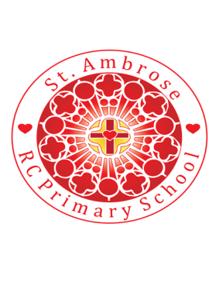

**Loving handsheartsminds.**

**Required for September 2024**

**Salary: Main scale**

**NoR: 190**

The Governing Board of St Ambrose RC Primary School wish to appoint a dedicated and motivated class teacher. St Ambrose RC Primary School is an inclusive, welcoming, primary school where expectations for behaviour and learning are high. We run a successful programme for continued professional development and work within system leadership contexts in support of the common good.

We are looking for a teacher who:

* Is committed to upholding and supporting the Catholic ethos of our school where everyone and everything is sacred;
* Is an excellent classroom practitioner with high expectations of pupils’ achievement and behaviour;
* Is able to ensure challenge, achievement and enjoyment for all children through interesting teaching and learning experiences;
* Is self-motivated and able to lead and work co-operatively as part of a team.
* Is able for adapt teaching to support the needs of all learners, including SEND.
* Is committed to take on the role as a subject leader and support the progress of the school development plan.

We offer the opportunity to work in a school which:

* Has a strong Catholic ethos, inclusive of mutual respect for all faiths and beliefs.
* Is committed to developing the whole child through an interesting curriculum offer;
* Has a dedicated, caring and motivated team of staff, who work together to provide a rich experience for our pupils;
* Values opportunities for continuing professional development and formation, encouraging staff to continue to learn and develop their knowledge and skills;
* Has happy, well behaved, confident and hard-working children who are a joy to teach;
* Is supported by a committed Governing Board and The Diocese of Salford, who take an active part in school life;
* Benefits from interested, involved and very supportive parents/carers;
* Values staff and develops them to make a significant contribution within the school.

**Teachers will be required to complete the CES teacher application form. The application form and further details are available from Mrs Helen Maguire (School Business Manager)** [**h.maguire@st-ambrose.manchester.sch.uk**](mailto:h.maguire@st-ambrose.manchester.sch.uk)

**All applications should be returned to** [**h.maguire@st-ambrose.manchester.sch.uk**](mailto:h.maguire@st-ambrose.manchester.sch.uk) **or by post to the school’s address**

Closing date: Monday 22nd April 2024  12noon

Shortlisting Date: Tuesday 23rd April 2024

Lesson Observations and Interviews: Thursday 2nd and Friday 3rd May 2024 (each candidate will only attend one date for both lesson observation and interview)

We warmly encourage all candidates to visit. Please contact Helen Maguire School Business manager on 0161 445 3299 to arrange this.

**Commitment to Safeguarding and safer Recruitment**

Our school is committed to safeguarding and promoting the welfare of children and young people and expect all staff and volunteers to share this commitment.  We will ensure that all our recruitment and selection practices reflect this commitment. The successful candidates will be subject to an enhanced Disclosure and Barring Service check along with other relevant employment checks.

The DBS Code of Practice is available at <https://www.gov.uk/government/publications/dbs-code-of-practice>.

The successful candidate will be required to sign the Catholic Education Service Contract of employment in order to maintain and promote the catholic character of the school.