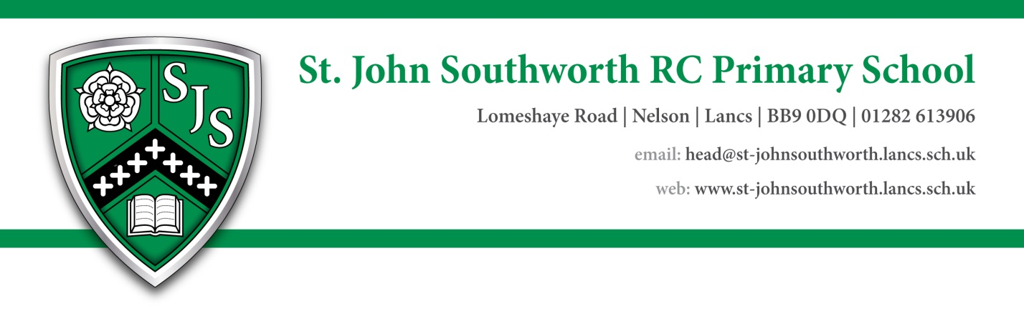

Teaching Assistant level 2a

The children, staff and governing body of St John Southworth RC Primary, a Voluntary Academy are looking to appoint a skilled, enthusiastic and highly motivated Teaching Assistant who will be a role model for our children and support them to achieve the best possible outcomes.   
  
This position is to support children with additional SEND needs working alongside the class teacher to support quality learning provision and to meet the specific needs of individual children.   
  
The successful candidate will:

* Be committed to upholding our school values, nurturing ethos and strong behaviour policy.
* Have experience of supporting children with SEND.
* Have a passion for supporting learning and development of children.
* Build strong and positive relationships with the children, class teacher and families.
* Enhance the learning opportunities for the children.
* Welfare Assistant duties are included within this role
* Work closely with the class teacher to ensure continuity of learning and quality first teaching.
* Be committed to whole school life and be willing to support extra-curricular activities and school events.

This will be a fixed term contract (subject to funding OR for the length of time the child is at St John Southworth School e.g. end of Key Stage 2) from 1st December 2024 or as soon as able after this date. With a possibility of an extension to the contract- subject to funding.  
The role is 28 hours and 45 minutes per week (8:45am- 3:30pm)

Essential Qualifications-

* Teaching Assistant Qualification or equivalent
* Maths and English qualifications (at least level 1 or above)

Desirable Qualifications-

* First Aid
* Safeguarding
* Prevent training
* Maths and English GCSE or equivalent

Essential Experience

* Teaching Assistant role previously
* SEND support experience and basic knowledge

Desirable Experience

* Supporting child/children with additional needs
* Experience of working with other agencies to support children.

For an informal discussion please contact school on 01282 613906.

Visits to school are warmly welcomed.

Proposed Interview Date 15th November 2024

Equal Opportunities statement An Equal Opportunities Employer welcoming applications from all sections of the community

Further information can be found at [www.**st**-**johnsouthworth**.lancs.sch.uk](http://www.st-johnsouthworth.lancs.sch.uk).