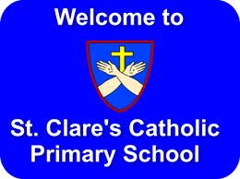

St. Clare’s R.C. Primary School

VACANCY

Teaching Assistant Level 2 – Permanent

Point 3 NJC Scale
Salary: £22 737 pro-rata term time only,
Full time 35 hours per week Term Time Only

The Governors of St. Clare’s R.C. Primary School are looking to recruit a Teaching Assistant Level 2. Qualification at TA2 level essential. At this stage, the successful applicant will be placed in Early Years. There may be a requirement to relocate to a different Key Stage in the future. All applicants must have a good level of numeracy and literacy in order to be able to support pupils at any stage throughout their primary career and be able to support our pupils in our faith journey. A knowledge and experience of using Read Write Inc would be useful.

In return we can offer:-

- Well behaved, happy children
- A strong team of supportive, committed colleagues
- Good support for career development

St Clare’s RC Primary School is fully committed to safeguarding and promoting the welfare of children and young people. This position requires an enhanced DBS disclosure.

We are an Equal Opportunities Employer and we positively welcome applications from all candidates regardless of age, disability, gender reassignment, marriage and civil partnership, pregnancy and maternity, race, religion or belief, sex and sexual orientation.

Closing Date for Applications: 12 Noon on Friday 6th September 2024
(Please Note: Applications received after this time/date will not be considered)

Interviews will be held week from 12th – 17th September 2024
Start Date: As soon as possible pending pre-employment checks

For an application pack, job description and person specification, please contact
the school via email on

recruitment@st.clares.manchester.sch.uk

