Teaching Assistant
Level 2

CONTRACT: | Permanent
WORKING PATTERN: | 35 Hours per week (8:00am – 3:30pm) term time + 1 week
SALARY: | TA Level 2 Grade 3, Points 4-6, £23,114 - £23,893 pro-rata (£19,884 - £21,012 actual)
Are you a determined, committed and capable individual with the skills and enthusiasm to ignite a passion for learning within our students and encourage them to use their full potential? Would you love to help our vulnerable students succeed and make progress academically, socially and emotionally?

We are looking for motivated and enthusiastic individuals, who would love to be part of our journey at The Barlow and could be instrumental in making a difference to our student’s education.

In this role, you will be working with students most of whom have Statements of Special Educational Need/Education Health Care Pan, or those who may be on the higher end of the SEND Support category across all subject areas and Key Stages. You would mainly be expected to work with students providing in class support. However, in liaison with class teachers you may also be as asked to take students out of lessons to work with them in small groups or on a one to one basis and be responsible for completing individual student action plans and profiles.

You should:
- Have experience of working with children with Special Educational Needs
- Have good literacy and numeracy skills
- Be aware of current national educational policy
- Have an awareness of the Special Educational Needs Code of Practice
- Have and understanding of the importance of safeguarding children.

In addition, you must be willing to undertake emergency first aid training.

In return, we will offer you the opportunity to further your professional development in a supportive and friendly environment.

For further details on the role please download the job description. Completed applications should be returned to hr@thebarlowrchigh.co.uk

Closing date: Wednesday 24th April 2024
Shortlisting: Thursday 25th April 2024
Interview: Week commencing 29th April 2024

About our School
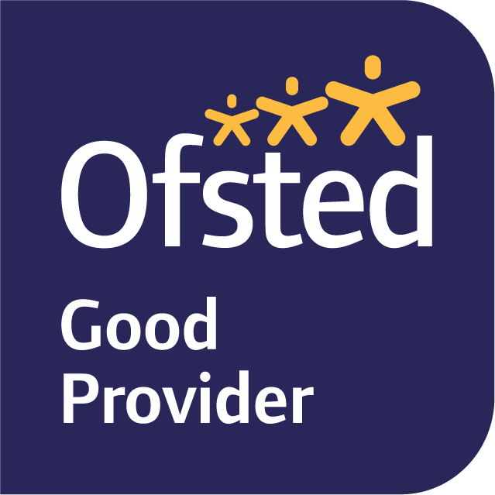
The Barlow is a highly successful, mixed, 11-16 Catholic comprehensive. In June 2019, Ofsted judged our school to be ‘Good’ in all categories. Public examination results are strong; above national average in most subject areas. We are a diverse and inclusive community, with high standards of pupil behaviour and a calm and purposeful learning environment. The school is located in Didsbury, a popular area of south Manchester, with excellent transport links.

Our school is committed to safeguarding and protecting the wellbeing of children and young people and expects all staff to share their commitment. An enhanced DBS is required for all successful applicants. To comply with our safer recruitment policy, successful candidates are also subject to a social media screening.

The Barlow RC High School
Parrs Wood Road
Didsbury, Manchester, M20 6BX
0161 445 8053
admin@thebarlowrchigh.co.uk
www.thebarlowrchigh.co.uk

