To love You more dearly
Material to support
The Prayer & Liturgy Directory

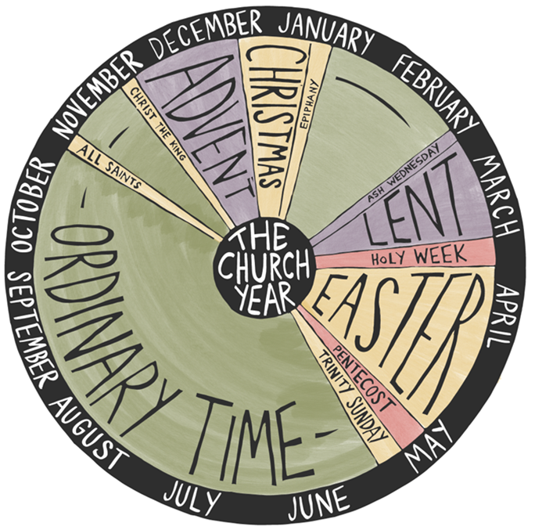

With information used and adapted from The Prayer & Liturgy Directory,
The Liturgy Office, the Diocese of Westminster, Spiritual Garments,
Redemptorist Publications, Praying in Color, Quiet Mind Project,
Jesuits in Britain, Pray as You Go, and CJM Music.
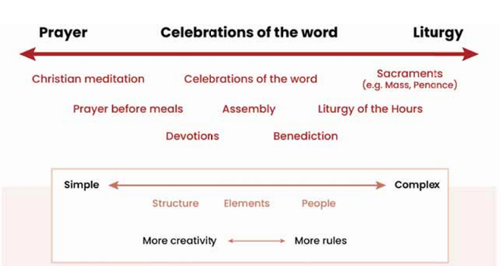
What is Prayer and Liturgy?
Prayer in all its forms is the ‘lifting up of the
hearts and minds to God’. ‘Liturgy’ to refers
to Mass and the sacraments, which are in
official liturgical books. Celebrations of the
word may take many forms but will involve
scripture and some elements of the liturgy.

Key elements of prayer and liturgy:
Participation - "full, conscious, and active".
- ‘fully’ means that everyone is involved and that the whole person is engaged through body, mind, and spirit;
- ‘consciously’ means we have an understanding of what is happening and that the prayer is appropriate for people’s age and development.
- ‘actively’ means an openness to God, so … our meeting with Christ can change us and have a direct impact on the way we live our lives.
Silence
- essential in any prayer or liturgy! Each silence is an opportunity to listen to the Holy Spirit speaking in our hearts and meet God at the heart of who we are. In liturgy, silence helps us to reflect on what we have heard and to prepare us for what’s next.
Scripture
- we are always going to include the word of God. God speaks to us today through the inspired words of the Bible writers. When the Gospel is proclaimed, it should be a high point and celebrated with signs of reverence.
Ritual
- a structured group activity that uses words, gestures, symbols, and movement that have been used by others over time. We use rituals to express significant things so, our prayer in school will be rooted in the liturgical year, sacraments and the school year.
Symbol
- usually come from the natural world – water, light, bread and wine, and oil.
Symbols can convey many different layers of meaning. It is best to use one appropriate symbol as a clear focus rather than many, which can be confusing.
Body
- our whole bodies are involved in prayer and liturgy – not just by what we say or sing. All our senses can be engaged: by the smell of incense, the splash of water, and the taste of the bread and wine in the Eucharist. Through art and music, our eyes and ears can be drawn deeper into the mystery of God’s love. We also use our bodies in movement with our posture and our gestures.
Music
- It is important that is right for the community. In Mass, singing the Gospel Acclamation and the Acclamations in the Eucharistic Prayer are more important than hymns. Where possible, try to involve regular singing in school.
Singing in Mass
pdf from the Liturgy Office: https://www.liturgyoffice.org.uk/Resources/Music/Singing.pdf
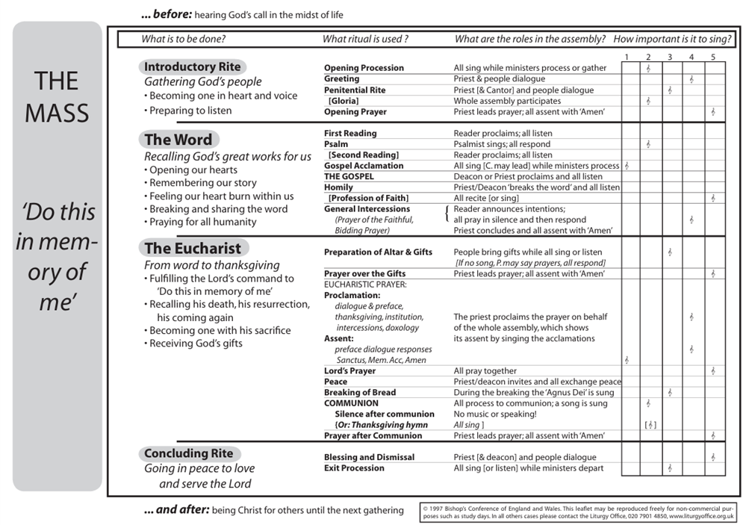
Guide to the Liturgical Calendar
The Liturgical Year begins on the First Sunday of Advent and runs through to feast of Christ the King, following the pattern of Jesus’ life, death and resurrection. The highlight of the whole year is Easter when we celebrate the paschal mystery, Jesus’ death and resurrection and the new life he has given us.
Liturgical colours
- Green is the colour of growth, new life and hope, like in nature. The green Sundays in the year remind us how much Jesus loves us and how love will grow when we share it.
- Purple is the colour of repentance; being sorry and trying to change. Lent and Advent are times of thoughtful preparation when purple is worn. Both these seasons have a Sunday of rose-pink to remind us of the joy we always have with Jesus.
- Red is the symbol for blood and for fire. Red on Palm Sunday and Good Friday help us think about Jesus’ suffering. At Pentecost we think of the fire of the Holy Spirit.
- White, or gold, is a colour of real joy and celebration.
Liturgical seasons
Advent | Begins on Sunday four weeks before 25 December. There are four Sundays in Advent.  Time of waiting and preparation  First section up to 16 December is a time of expectation for Christ’s second coming. The second section looks forward to Christ’s birth.
Christmas | Begins Christmas Eve and ends on the Baptism of the Lord, the Sunday after the Epiphany.  Extended time of reflecting on the meaning for us of Christ’s birth
Ordinary Time | Begins on the first Sunday after the baptism of the Lord (mid-January)  Not a season as such but a period of marking the weeks between the seasons of Advent/ Christmas Lent/ Easter.  ‘Ordinary’ as in counting, not plain or uninterest.  A time of hearing the scriptures unfold week by week with a continuous reading of one of the Gospels  There are three yearly cycles for the Sunday readings: Year A is Matthew, Year B Mark, Year C Luke  The weeks are counted from number 2 until lent begins then break off and resume after Trinity Sunday
Lent | Begins on Ash Wednesday and ends on the evening of Maundy Thursday.  There are 40 days, six Sundays in length (‘Lent’ is thought to mean ‘length’ as the days of spring are getting longer.)  The fourth Sunday is Mother’s Day in the UK and the sixth Sunday is Palm Sunday.  A time when the unbaptised (catechumens) prepare for their baptism at the vigil on Easter Saturday night and the whole community recalls its baptism by fasting praying and doing acts of charity.  The word ‘Alleluia’ (praise to God) is not used.
Paschal Triduum | The three days from sunset on Maundy Thursday through Good Friday and Easter Saturday to the sunset on Easter Sunday.  This is the centre of the Church’s year from which all the other seasons flow.
Easter | Begins on the evening of Easter Sunday and ends on Pentecost Sunday when we celebrate the gift of the Holy Spirit to the Church and each of us (sometimes called Whit (white) Sunday although red vestments are worn on this day now.)  There are 50 days, a week of weeks plus one day = the time of eternity.  Gospel readings are taken from John, first readings are a sequence of readings from the new testament Acts of the Apostles (instead of the old Testament)  The symbols of water, light and fire prevail with a decorated Easter candle given most prominence.  The word ‘Alleluia’ is sung as frequently as possible.
Ordinary Time | The weekly counting of the Sundays resumes after Trinity Sunday, which is one week after Pentecost Sunday and ends before the first Sunday of Advent

Prayer Boxes – may be useful in each classroom with the following possible content:

OBJECT | NOTES
Cloths | Liturgical colour include:  • green for ordinary time;  • white for Christmastide and the Easter season;  - purple for Lent and Advent;  • red for martyrs’ feast days/Pentecost/Holy Spirit;  • gold can be used in place of white;  • pink for Gaudete Sunday during Advent and Laetare Sunday during Lent;  • blue for Marian feasts.
Cross/crucifix | This should be age appropriate. There are lots to choose from and the pupils could be actively involved in this. If setting it on the table, it might be useful to consider how it can be raised so it can be seen.
Bible/prayer book/stories of Jesus | ESV is suggested. This should be age appropriate. Ideally, pure scripture will be used and be linked to the liturgical year eg Sunday’s Gospel and the text will be changed regularly to reflect the liturgical season/RE topic/theme.
Plant/flowers | These can be real/artificial/made by pupils. If they are real, pupils could take responsibility for looking after them.
Candle | This may be artificial depending on the age of pupils.  Consideration must be given to the storage of matches/lighters for health/safety reasons. These can  reflect the liturgical season/theme.  Candles may be designed (safely!) with images/ Scripture.  Various colours and shapes might be used to link to the season/theme.
Rocks/stones/pebbles | These can symbolise a variety of things including the Earth. Pupils can make different shapes for them (eg cross/heart).
Images/icons | These can link to various themes etc and can be of various styles (eg Jesus, the Holy Spirit). They may be created by pupils.
Words/letters/Scripture | These can be versatile or specific. For example, packs of wooden letters can be changed to suit the theme. Scripture can be written on card/wood/ stone etc or framed.
Statues/objects | These can be linked to school/class saint or the liturgical year eg Mary. It is useful to have abstract ones which can suit various themes eg praying hands, family, friends etc
Holy water/oil | These could be used for blessing each other during prayer/worship. They could also be used simply as visual symbols. (Fragranced) oil could be used be burned and linked to the Liturgy providing it is done safely.
Pupil Participation
Important note to remember | All pupils are valuable in their participation simply be being present – there is not just an emphasis on ‘doing’ but also in ‘receiving’ – both roles are equally important.
Opportunities  for pupils to lead | - Plan using the Celebration of the Word planning sheets and cards  - Set up a focal area with different symbols/images linked to theme  - Get the music ready. Choose an alternative song or scripture if appropriate  - Complete the activity beforehand to model what pupils can do  - Prepare a PowerPoint based on the ideas given  - Choose alternative activities eg write a short song or poem based on this scripture and offer these as prayers  - Link this to learning in class, the liturgical year or quotes from special people
Pupil  involvement  BEFORE worship | SETTING UP  - Sorting song words  - Selecting and setting up CD/ICT  - Putting out/moving chairs  - Preparing prayer table  WELCOMING  - Greeting (eg at door)  - Meeting visitors at entrance  PLANNING  - Using the planning sheet and cards  - Choosing music/songs  - Finding or writing prayers; choosing others’ prayers  - Preparing video and visual materials  - Training for new helpers
Pupil  involvement  DURING worship | GATHERING  - Singing as others arrive  - Lighting candle  - Saying a welcoming sentence/greeting  ENGAGING  - Introduce a visitor/pupil etc  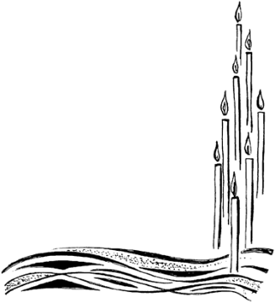  - Share the word (eg on screen)  - Drama  - Holding props  - Telling or reading the story  - Showing a clip  RESPONDING  - Asking and answering questions  - Reading or saying prayers  - Leading prayer  - Singing or playing instruments  - Leading actions or signing to songs or prayer  SENDING  - Explaining the Mission  - Giving examples  - Distributing resources eg bookmark, challenge/mission  - Saying closing prayer  - Choosing music/songs  - Blowing out candle
Pupil  involvement  AFTER worship | CLEARING UP  - Supervising pupils leaving respectfully  - Holding doors  - Putting away equipment  RECORDING  - Leading evaluation (asking others what they thought)  - Complete a CW record form for evidence file  EVALUATION  - Record evaluation (own and others’)  - Share evaluations with REC/ HT/ CT/clergy/governors/School Council as required
EVALUATIONS  REFLECTIONS  (Examples of questions the  Chaplaincy Team can discuss with each other and other pupils. Pupils could choose which ones to discuss and rotate these as necessary.  They may come up with their own  questions also) | - How did it make you feel?  - Has it helped you to understand more about God? How?  - What did it make you think about?  - What have you learnt?  - Did you find out anything new about yourself or others?  - Do you think you will behave differently as a result of it?  - Did it give you a chance to pray if you wanted?  - Do you want to ask anything about what you heard about/experienced?  - What did you enjoy about it? Why?  - What will you remember about it?  - What might you have done differently?  - How do you think it might be improved?  GATHERING  - Is there a sense of calm, excitement, respect, community?  ENGAGING  - Is it engaging and appropriate for all present? Eg does it have story, song, visitors, questions, images, meaningful resources?  RESPONDING  - Is there space for pupils’ response? Eg is there singing, praying, discussion, sharing, action, silence?  MISSION  - Is there a sense of mission? For example, do pupils leave with a sense of purpose, challenge, resolve, blessing?
Structure

The basic structure in prayer and liturgy is a call and response: God speaks to his people in his word (the scriptures), and they respond. It is God who takes the initiative and who speaks, and we who
listen and respond

This creates a four-part structure:
• Gather
- Silence
- Seating
- Lighting
- Music
- Voice
- Focal Point
• Word
- Listen with our heart
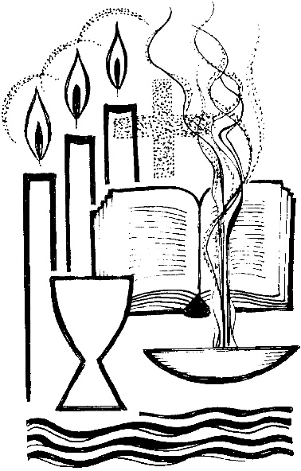
- Liturgical Year
- Wonder questions
- Ignatian, imaginative reading
- Lectio Divina
• Response
- Reflection
- Writing
- Sharing
- Drawing
- Visio Divina
• Send
- Putting our love into action

Prayer changes us and makes no sense without action!

This four-part pattern is very flexible. Each part can be simple or elaborate. To gather, we might
just light a candle and be silent, or make the sign of the cross, or our gathering might be the
Introductory Rites at Mass. For celebrations of the word, the context of the celebration may
therefore affect the relative weight of the different parts. A leaving celebration, for example, may
extend the dimension of sending.
PLD 7.3

Celebration of the Word Planning Sheet.
Gospel: God’s word is where we start - which Gospel are we using? (Gospel of the day? /Sunday’s Gospel?)
After reflecting, our theme is:
- Are we using a different passage of scripture?
- What is the Gospel (or Bible reading) saying?
- What is the liturgical season?
- Are there any significant feasts or celebration days?
- What is happening in school now?
- Is there anything else that we want to pray about?
Gather  How will we create the right mood/ atmosphere?  Seating? Music? Lighting? The Quiet Mind Script?  What will our focal point look like:  Do we have a cloth to reflect the liturgical season?  Will we have a cross, Bible or candle?  Maybe a symbol connected to the Gospel?  Who will welcome everyone and how?  How will we introduce our theme?  How can we link it to people’s experience?  How will we start our prayer? | Word  Where will the Bible be?  How will we help people to respect God’s word, to know this is a special time?  Who will read?  Who will help them understand the reading?  When will they practise?  Will we help people listen to God speaking to them with silence, wonder questions, Lectio Divina or Ignatian, imaginative prayer?  How will we do this?
Respond  How will we respond to the Bible in a prayerful way?  Will we use silence /art/ music / writing / a symbolic action - or something else?  Which of our senses are we using?  How/ when will you distribute the resources, so the prayerful atmosphere is not disturbed?  Will we give them out first?  How will we draw this time of response to a close? | Send  What message do we want people to take away?  Do we want them to decide for themselves?  How will we help them do this?  Which prayer will we share together to close this celebration of the word?  What will the final message be? Who will say it and how?
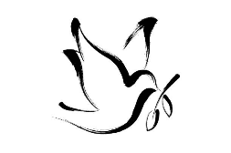
We begin in prayer, asking the Holy Spirit to guide our planning
Celebration of the Word Planning Sheet.
Write your decisions – or put your planning cards – on this plan
Gospel: Theme:

Gather  We come together as part of God’s family. | Word  God speaks to us and we listen.
Respond  We take the time to engage and reflect more deeply. | Send  We want to share the Good News!
Creating a focal point
Prayer is not something done for children but rather a celebration with them. Arranging the worship space is a ministry, pupils can be involved in preparing a worthy and appropriate space for prayer. Using visual objects will help to convey meaning to our pupils. Symbols will reveal something of God, maybe not immediately but over time in a continuous process.

Liturgical year - how can we reflect which season we are in? Can we use cloths? Will we use a devotion such as an Advent wreath, Christmas crib or a rosary?

Symbol - which symbols can we use to help people know this is a prayer space eg a candle to remind us that Jesus is the light of the world; Book of the Gospels to remind us that God is speaking to us through God’s word which is central to our prayer.

Theme - Have we got a focus for our prayer that we can reflect on our focal point? eg a net if Jesus is calling us to be fishers of people.

Season - is our natural season something we want to use as a focus? Autumn leaves or spring flowers can help to engage pupils and bring what is happening in our lives to God in prayer.

Personal - can we bring anything from home that means something? Is there space to place our prayers on the focal point eg post-its around a candle / in a basket?

Simple - we don’t want to over complicate and confuse people with too many symbols. Can we pare it back at all?

Beautiful - is this focal point something that invites us to look, and so enter more deeply into a time of prayer?
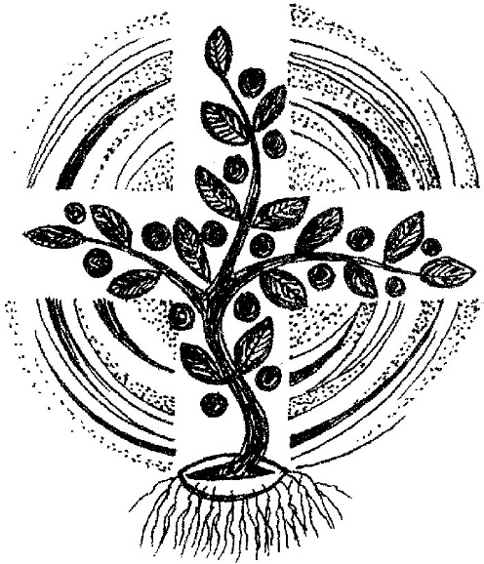

Quiet Mind Script
(a way into Christian meditation)
Meditation is at the heart of many prayer traditions and very much part of the Catholic tradition. In addition, the value of a time of quiet in the day is recognised by psychologists and recommended for everyone, regardless of a personal faith. We are going to have some time to quieten our minds. I understand that this may be difficult for some and with practice it will become easier to do. I want you, however, to take part and benefit from what it can bring. I will lead you in some relaxation, and then we will have (insert time: 30 seconds / 1 minute / 2 minutes) of silence
As we start this day, we remind ourselves that God is present with us, that God is the way to our true selves. God made us to be all that we are. We are wonderfully made. We are not on our own.
God knows us intimately and loves us. We trust God. Let us quieten our minds, be still and know God.

Quiet Mind Project Script
Put your feet flat on the floor..
Straighten your spine.
Forget everyone else in the room.
Gently close your eyes.
Be aware of the top of the head, relax your forehead, your face, your throat, shoulders, neck, your front and back; now relax your arms, legs and feet.
Try to quieten your mind – if thoughts come in, just let them go.
Listen to the sounds around you.
Without changing it, focus on your breathing.
Breathe in. Breathe out.
Breathe in feelings of calm.
Breathe out and let go of anything that is worrying you.
Breathe in: “Be still” Breathe out: “And know”
Be still. And know.
[silence for 30 seconds / 1 minute / 2 minutes]
Now be aware of your breathing again
Listen to the sounds around you
Be aware of the top of the head, relax your forehead, your face, your throat, shoulders, neck, and your front and back; now relax your arms, legs and feet.
You can open your eyes now and be ready to start the day in a calm way.
Ignatian Prayer
(taken from https://www.jesuit.org.uk/spirituality/imaginative-contemplation)
Imaginative contemplation was developed by St Ignatius of Loyola and the Jesuits who follow his teaching. It is all about getting to know Jesus by using your imagination to place yourself in in a Gospel scene, stepping into the story and meeting Jesus there.

1 Imagine the place
The first step in an Imaginative Contemplation exercise is setting the scene.: What is the location? What does it look like? What details do you see?
2 Engage all your senses
Imaginative contemplation goes beyond just what you can see, it requires you to engage all of your senses so you are fully immerse yourself into the story; this means exploring what you smell, hear, taste and touch.
3 Let the scene play out
Let the story unfold and allow yourself to be drawn into what has captured your imagination. Sometimes people are not drawn to the main action of the story but towards other things. When this happens, just allow yourself to follow what you are naturally being drawn to. It is important to understand that you are not just watching the scene play out as though it is a scene from a film. Instead, see yourself as a character inside the story.
4 Open your heart to Jesus
Finish with a conversation in your imagination between Jesus and yourself, as one friend speaks with another. Say what is in your mind and heart and let Jesus express his responses too.
5 Reflect on your experience
After the contemplation has finished, it is very important to take some time to reflect on what you noticed. Look back at your prayer and honestly ask yourself:
- What did I find myself thinking and feeling? What moved me?
- What struck me and why did I react the way I did?
- Did anything in the contemplation change the way I see God, myself, or others?
- How did Jesus’ words or actions in the contemplation make me feel?

Lectio Divina: listening with the heart
(taken from https://pray-as-you-go.org/series/16-How+to+Pray+with+Lectio+Divina )
Lectio Divina is a Latin phrase meaning, ‘Godly reading’. It is a simple, yet profound method of prayer found in many traditions of Christian spirituality. Sometimes it is called 'meditative reading' or 'spiritual reading',
The 'lectio' of Lectio Divina is a listening with the heart, as you tend to do quite naturally when you are struck by the beauty of a sunset or you pay attention to someone you love. In praying this way, you hear a scripture passage or other sacred text and you let God guide your heart.
You read slowly, with pauses, and a natural process takes place: heartfelt listening moves into a deep reflection upon the words and the silences between them; and that deep reflection leads you to some kind of heartfelt response. You find yourself speaking from the heart to the God who has spoken to you.
A Guide for Lectio Divina
Beginning: Jesus Christ is revealed to us through his holy word, whenever we read the Scriptures or hear them proclaimed at Mass. Through Jesus we come to know the Father. Have your scripture passage ready in front of you and become comfortable with it. Read it over a few times to get past any questions that arise about meaning. Invite God to speak to you through the text. Ask for openness. Let yourself settle into an expectant stillness.
This kind of prayer has four 'phases' that you move between as you feel drawn: lectio (reading), meditatio (meditation), oratio (prayer) and contemplation (contemplation).
Lectio (reading)
Read slowly and gently, listening with your heart to the words. There is no need to rush. No need to get to the end of the passage. When a particular word or phrase strikes you and seems to have some savour, linger with it …
Meditatio (meditation)
… let it into you. Pause with it. Let the word or phrase resonate. Repeat it to yourself, relish it, let it echo and soak into you until the 'flavour' begins to go, then …
Oratio (prayer)
… let yourself respond in prayer, in words from the heart, or a space full of silence, or spontaneous, unspoken feeling. Whenever the moment feels ripe, begin to read again …
Contemplatio (contemplation)
…now spend some time pondering what God has been saying, and what you think you need to take away from this prayer time.
If praying in a group, after some time of quiet, starting with you, go around the circle inviting everyone to share a sentence of what they are taking away from this prayer time – but without pressure to do so.
Ending
When you are ready, mark the end of your time of prayer with the sign of the cross or words of prayer.
Visio Divina: seeing with the heart
Visio divina is a way of praying by looking at art. It means “divine seeing” in Latin. It is like lectio divina, but instead of reading scripture, you focus on an image. You let God speak to you through what you see. Both lectio and viso divina are ways to listen to God. Both invite you to slow down and pay attention.

Spending time with art in a prayerful way can help us notice things we might miss otherwise. The colours, the light, the expressions on people’s faces—these little details can reveal something about God’s love, mercy, and presence in the world. Art has a way of speaking to us without using words. It can stir emotions, bring back memories, or make us think about things in a new way. You don’t have to be an artist to pray this way. You just need to be open. Look at an image and let it speak to you. What stands out? What feelings come up? Maybe a certain part of the image reminds you of something in your life. Maybe it connects to a Bible story or a struggle you’re facing.

- Visio divina begins with prayer. Ask the Holy Spirit to guide you. Invite God to speak through the image you will see. Take a moment to quiet your mind and be open to God’s presence.
- Take a deep breath and look at the artwork with fresh eyes. What do you notice? What strikes you first about the image? Do not rush. Let the image unfold before you. Visio divina is not about judging art but about letting it speak to your heart.
Notice the colours, the light, and the shadows. Look at the faces, hands, and background. Pay attention to every small detail.
- As you look, be aware of your feelings. Does the image bring peace, sadness, or joy? Does it remind you of something in your life? Let your thoughts flow naturally. Do not force meaning.
- Listen for God’s voice in the silence. Visio divina is not about analysing art. It is about letting God speak through what you see. Be open to God’s message, even if it surprises you. Stay with the image as long as you need. Let it guide your prayer. If a certain part of the artwork draws you in, focus on it. Let God use it to speak to your heart.
- Visio divina is not just about looking at art. It is also about responding to what God shows you. After spending time with the image, take a moment to reflect. Did something stand out in a new way? Think about how God may be speaking to you through visio divina. Does the image call you to change something in your life? Does it remind you to trust God more? Maybe it brings up a memory or a struggle that needs attention. Be honest with yourself and with God.
- Your response to visio divina can take many forms. You may feel moved to pray in gratitude for a blessing. You may feel called to repent for a sin or weakness. You may feel inspired to take action, such as helping someone in need. Let your prayer lead to a real response in your life.

Biblical themes like forgiveness, trust, and holiness can become clearer through visio divina. A painting of the Annunciation can remind us of Mary’s faith and obedience. An image of the Last Supper can help us reflect on the Eucharist. Looking at these scenes slowly and prayerfully helps us enter into the mystery of our faith. When we use visio divina, we allow sacred images to teach us and draw us closer to God.
By praying with sacred art, we make the Bible part of our daily life. We do not just read about God’s love—we see it. Visio divina helps us reflect on Scripture, grow in faith, and listen to God’s voice in a new way.
Guide to writing prayers
The Collect or Opening Prayer
The Opening Prayer is traditionally called the “Collect” because it gathers everyone’s prayers into one. The Collect usually ends the Introductory Rites of the Mass. The priest will say, “Let us pray,” and then leave a period of silence. The silence is important because, having already become aware that we are in the presence of God, we now think about what we want to pray about during Mass. The Collect often refers to the feast day the liturgical season or the readings. This type of prayer would also be a really good way to start any time of prayer in school, introducing the theme.
Address God, a person of the Trinity, by a meaningful title
- Almighty, ever-living God,
- Loving Father,

- who wonderfully created the dignity of human nature,
- who in the abundance of your kindness surpass the merits and the desires of those who entreat you,

- grant, we pray, that we may share in the divinity of Christ, who humbled himself to share in our humanity.
- Pour out your mercy upon us to pardon what conscience dreads and to give what prayer des not dare to ask

- Who lives and reigns with you in the unity of the Holy Spirit, one God, for ever and ever.
- Through our Lord Jesus Christ, your Son, who lives and reigns with you in the unity of the Holy Spirit, one God, for ever and ever.
Name

recall something awesome about God’s marvellous deeds
Recall

In the light of what God has done, what do you hope God will do?
Request

A simple or traditional Trinitarian ending (which varies depending
on which person of the Trinity in invoked at the beginning)
Close
- ((we ask this) Through Christ, our Lord.
The Prayer of the Faithful or Bidding Prayers
In Mass, these prayers are said after the readings and the priest’s homily. They are not mini prayers to God but ask everyone to pray together for certain people or things. The intentions should be short, clear and easy to understand. They are “we” prayers more than an “I” prayers. This means that the bidding prayers include special intentions in a way that opens them to lots of people. eg instead of “I pray for my Aunt Jane, who is sick,” it’s better to say, “We pray for Jane Smith and for all those who are sick, that they be healed and touched by God’s peace.”
The traditional recommended order for intentions is:
1. For the needs of the Church, 2. For the world, 3. For those in need, 4. For the local community.
In particular celebrations the bidding prayers might relate to the occasion eg Advent or the beginning of the school year. It is important to remember that intentions should not begin ‘Dear God’ or ‘Dear Jesus’ - they are addressed to everyone there who then pray before all the prayers are gathered in the response.

The overall structure of the Prayer of the Faithful is:
  - Introduction (the priest invites everyone to pray)
  - Intentions (Opening phrases: Let us pray for… We pray for… We pray that… or ‘For . . .)
  - Silence for prayer
  - Response (sung or said eg Lord, in your mercy. Hear our prayer. Lord, hear us. Lord, graciously hear us)
  - Concluding prayer (the priests says a collect which everyone responds to with “Amen”)
Praying in Colour
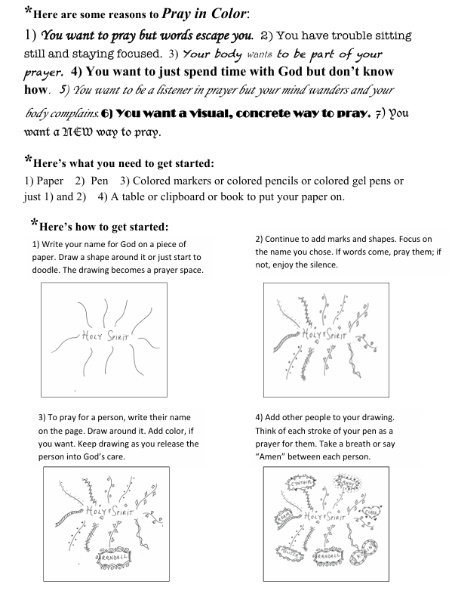
Praying in Colour = prayer + doodlinghttps://prayingincolor.com/praying-in-color

Weekly diocesan prayer powerpoints
- The weekly powerpoints are designed to support staff preparing and leading prayer in schools, both primary and secondary. Please adapt the resources for your group. Following the four-part structure that the Prayer and Liturgy Directory encourages, Gather, Word, Response and Send are identified on each powerpoint. While there are some supporting resources on the Diocesan website, we have tried to keep as much as possible on the powerpoint, to save time for busy staff.
- Before using any of the resources, take the time to create a calm and prayerful atmosphere, perhaps with quiet music, dimmed lighting and using the Quiet Mind script to still the group.
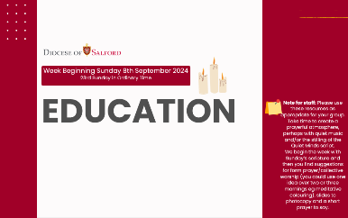

What is on the weekly powerpoints?
- The first slide identifies the liturgical week
and Salford’s suggested prayer theme.
- Have the “Be still” slide on the screen while pupils are guided into stillness, perhaps using the Quiet Mind script. The script is on the following slide, but not designed to be shown to pupils. Along with some background information, it is also in Supporting Resources. A time of quiet meditation might be the most appropriate regular prayer for your group without the use of any further resources.
- We begin the powerpoint with Sunday’s scripture. If the whole Gospel is long for your group, the slide following has a significant verse taken from the Gospel to use. Choose another if it is more appropriate. This may be an appropriate time to introduce your group to the responses used in Mass.
- We have then provided a brief explanation of the Gospel, making links to the week’s prayer theme. This is designed to support non-specialist staff, not meant to be read to pupils. It may also be appropriate here to introduce to your group the responses used in Mass.
- You will then find two or three suggestions for form prayer/collective worship on the remaining slides. Use and adapt them for your group as a way to respond to God’s word in the scripture and a potential way to live out the message. You may choose just to use one over a number of days, some might be used as part of a Celebration of the word or at a voluntary prayer group. For ease, we have tried to provide any suggested resources to be photocopied on the powerpoint itself.
- Each suggested activity has a short prayer to say collectively, to draw your reflection together.

