Resource Provision
Teaching Assistant Level 3

CONTRACT: | Permanent
WORKING PATTERN: | 35 Hours per week (8:00am – 3:30 pm) term time + 1 week
SALARY: | TA Level 3 Grade, 4 Points 7-11, £24,294 - £25,979 pro-rata (£20,892 - £22,848 actual)
Are you a determined, committed and capable individual with the skills and enthusiasm to ignite a passion for learning within our pupils and encourage them to use their full potential? Would you love to help our vulnerable students succeed and make progress academically, socially and emotionally?

We are looking for motivated and enthusiastic individuals, who would love to be part of our journey at The Barlow and could be instrumental in making a difference to our student’s education.

You will be predominantly based in the Resource Provision undertaking specialist support with our pupils with a diagnosis of autism, taking a lead role in addressing their needs to help overcome barriers to learning. You will deliver intervention programmes supporting individual pupils and small groups.

You must:
- Have NVQ level 3 Teaching Assistant qualification or equivalent qualifications or experience
- Have experience of working with or caring for secondary aged children.
- Have experience of working with pupils with additional needs, in particular children with social, emotional or mental health difficulties
- Have an understanding of the Early Help Assessment framework for Manchester
- Have good literacy and numeracy skills
- Have the ability to work pro-actively and re-engage pupils within challenging situations

Previous experience of working with young people with autism would be an advantage. In addition, you must be willing to undertake emergency first aid training.

In return, we will offer you the opportunity to further your professional development in a supportive and friendly environment

For further details on the role please download the job description. Completed applications should be returned to hr@thebarlowrchigh.co.uk.

Closing date: Wednesday 24th April 2024
Shortlisting: Thursday 25th April 2024
Interview: Week commencing 29th April 2024
About our School
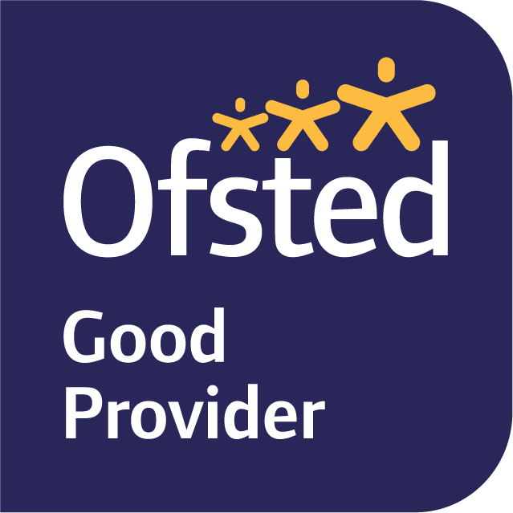
The Barlow is a highly successful, mixed, 11-16 Catholic comprehensive. In June 2019, Ofsted judged our school to be ‘Good’ in all categories. Public examination results are strong; above national average in most subject areas. We are a diverse and inclusive community, with high standards of pupil behaviour and a calm and purposeful learning environment. The school is located in Didsbury, a popular area of south Manchester, with excellent transport links.

Our school is committed to safeguarding and protecting the wellbeing of children and young people and expects all staff to share their commitment. An enhanced DBS is required for all successful applicants. To comply with our safer recruitment policy, successful candidates are also subject to a social media screening.

The Barlow RC High School
Parrs Wood Road
Didsbury, Manchester, M20 6BX
0161 445 8053
admin@thebarlowrchigh.co.uk
www.thebarlowrchigh.co.uk

