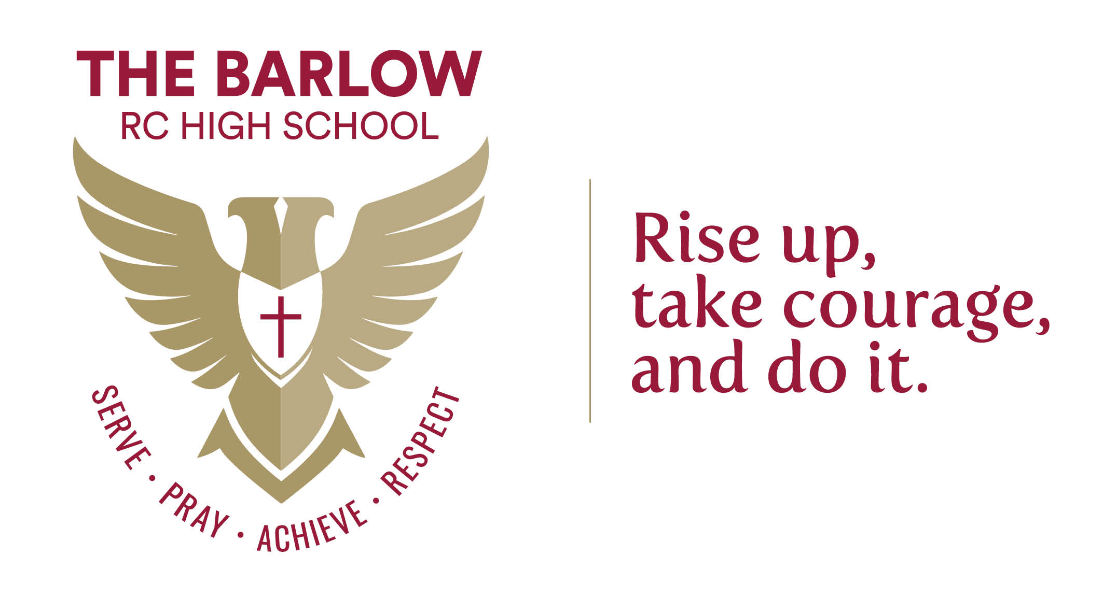

RECEPTIONIST

Do you have experience in customer support? Do you like a varied and reactive role? Are you a people person? Could you be the face of The Barlow?

Do you want to work with young people, to support them to grow and develop and overcome barriers to learning?

Are you resilient and enjoy a challenge?

Are you computer literate, with good literacy and numeracy skills?

Are you looking for a permanent role?

Is it important for you to work in a supportive team that are passionate about improving standards and processes?

Do you want to work in a diverse and inclusive community, with high standards of pupil behaviour and a calm and purposeful learning environment?

If so, this could be the ideal role for you. We are located in South Manchester with great transport links.

We are seeking a permanent part-time receptionist.

The Barlow holds the Gold Standard Award for excellence in staff wellbeing and is an employer that provides continuous professional development and job stability.

You will benefit from:
- Working with young people
- Great working hours
- Job stability
- Local government pension scheme
- Access to varied training programmes and online training
- Employee Assistance Programme
- Cycle to work scheme
- Access to electrical vehicle charging points with reduced tariffs for staff
- A supportive team and working environment
- A challenging, interesting and varied role

Important Details:
- Contract: Permanent, part-time, term time plus 3 days
- Salary: Grade 3, Points 4-6 - £23,114 to £23,893 (£13,632 - £14,410 pro rata) + pay increase pending
- Working Pattern: 24 hours a week, Monday-Wednesday, 7:30am – 4:00pm
- Pension: Greater Manchester Pension Fund with employer contributions of up to 17.2%
- Location: Parrs Wood Road, Didsbury, M20 6BX

Duties of the Receptionist:
You will work independently from the reception area to:
- Present a professional yet welcoming and friendly persona to visitors
- Prioritise workload, multi-task and keep calm under pressure whilst working in a busy, faced paced environment
- Be customer focused and be able to deliver a high standard of customer service

The Receptionist must:
- Possess excellent communication skills, being able to communicate at all levels
- Be able to deliver a high standard of customer service
- Have good IT skills
- Have the ability to work independently
- Be self-motivated and able to multi-task
- Be pro-active and highly organised
- Enjoy a challenging, varied and reactive role
- Like working with children
- Ability to ensure school policy is being adhered to in day-to-day practice
- Ability to follow and implement safeguarding regulations (training provided)

Advantages:
- Previous experience in other relevant roles

Are you the Receptionist we have been searching for?

If so, please get in touch - call the HR team 0161 438 2108, send over your CV, or complete and return an application form to hr@thebarlowrchigh.co.uk

Closing date: Tuesday 12th November, 8.00am
Interview: Week beginning Monday 18th November

About our School
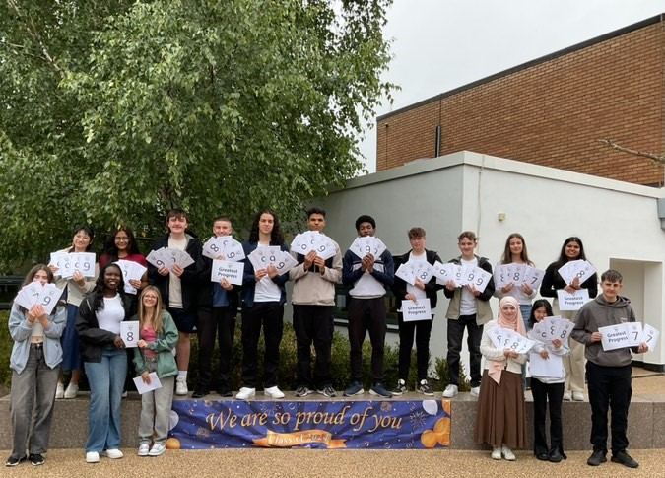
The Barlow is a highly successful, mixed, 11-16 Catholic comprehensive. In June 2024, Ofsted judged our school to be ‘Good’ in all categories. Public examination results are strong; above national average in most subject areas. We are a diverse and inclusive community, with high standards of pupil behaviour and a calm and purposeful learning environment. The school is located in Didsbury, a popular area of south Manchester, with excellent transport links.


The Barlow RC High School
Parrs Wood Road, Didsbury, Manchester, M20 6BX
www.thebarlowrchigh.co.uk
 0161 445 8053

Our school is committed to safeguarding and protecting the wellbeing of children and young people, and expects all staff to share their commitment. An enhanced DBS and social media screening is required for all successful applicants.

