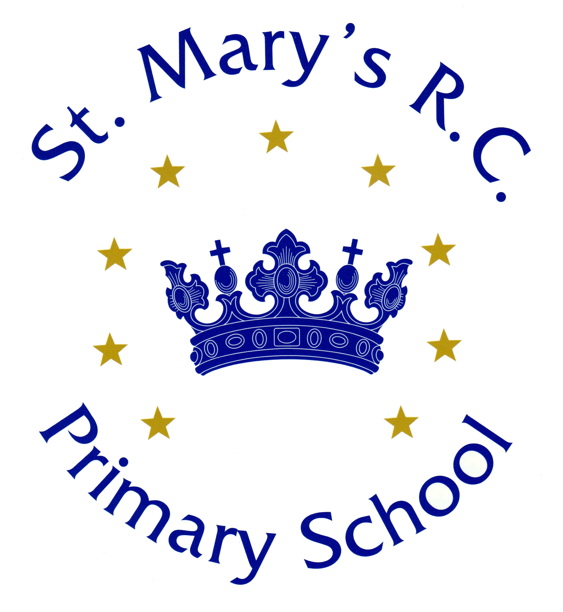

Intervention/ PPA Cover Teacher
Education - School
Teacher
St Mary’s RC Primary School, Swinton
St Mary’s RC Primary School
Milner Street
Swinton
M27 4AS

Intervention/PPA Cover Teacher- EY-Y6
Working Hours: 32.5
Contract Type: Temporary 1 year contract from 1st September 2024
Closing date: Thursday 9th May 2024
Shortlisting Date: Monday 13th May 2024
Lesson Observation and Interview: Thursday 16th May 2024

The Governing Body of St Mary’s RC Primary School seek to appoint an experienced and enthusiastic teacher to join our high performing school from September 2024. The successful candidate will share our aim to unlock the potential within every member of the school by lovingly nurturing individuals and watching them grow into confident citizens.

Applications are welcomed from experienced teachers (M3-M6)

The successful candidate will:

● be a committed and ambitious practitioner who will ensure high levels of achievement for our pupils to succeed.
● be able to plan lessons for pupils to achieve and make good progress.
● have an excellent understanding and knowledge of the National Curriculum requirements for KS1 and KS2 and the Early Years Curriculum.
● be keen to develop reflective practice.
● have a clear understanding and commitment to the Catholic ethos of our school.
● have a desire to continuously develop within their profession.
● be willing to contribute to the wider life of the school.
● foster effective relationships with all stakeholders.

As a school we can offer:

- a caring and welcoming school with a strong Catholic ethos.
- confident and enthusiastic children who are eager to learn.
- a friendly, hard-working, experienced and dedicated staff team.
- excellent opportunities for continued development.
- a supportive and committed senior team, governing body and parent community.

We warmly encourage all candidates to visit the school. Please contact the school office on 0161 794 4028 to arrange this.

The successful candidates will be required to sign the Catholic Education Service Contract of employment in order to maintain and promote the catholic character of the school.
Please download and complete the attached CES Teaching Staff Application Form and return to dee.raynor@salford.gov.uk or by post to the school’s address.

https://www.stmarys-swinton.co.uk/new-vacancy/

The school is committed to safeguarding and promoting the welfare of children and young people and expects all staff and volunteers to share this commitment. This post is subject to a fully enhanced DBS check.

If you have lived or worked abroad for 3 months or more in the last 5 years or 12 months or more (whether continuously or in total) in the last 10 years whilst aged 18 or over, please refer to the link below for details for how to obtain your Certificates of Good Character.
https://www.gov.uk/government/publications/criminal-records-checks-for-overseas-applicants

Continuous service commitment
New employees can now keep their service related benefits when moving between a whole host of public sector organisations within Greater Manchester, which include: Councils, NHS, Greater Manchester Fire and Rescue, Transport for Greater Manchester, as well as many others.

Diversity and Inclusion
We are committed to developing a culture which respects individuals, appreciates difference and allows everyone regardless of background to reach their full potential. We are proud to be an accredited disability confident employer and a Stonewall Diversity Champion. We understand how hard it can be to combine caring for a loved one with work so we aim to provide support and flexibility to balance family and caring responsibilities with work https://greater.jobs/content/9189/diversity-and-inclusion

Our core data protection obligations and commitments are set out in the council’s primary Recruitment and Employment Privacy Notice which can be found at https://www.salford.gov.uk/gdpr

We have made a commitment to improve the employment opportunities for people with disabilities, care leavers, carers, and ex-military personnel by way of a Guaranteed Assessment Scheme. Our application forms ask you to indicate if you meet any of the criteria within this scheme, and so to find out more and if you qualify please visit:
Greater Manchester Guaranteed Assessment Scheme

salary from
£33,800
contract
temporary
working hours
full time
application deadline
12 00 pm
Thursday 9th May 2024

