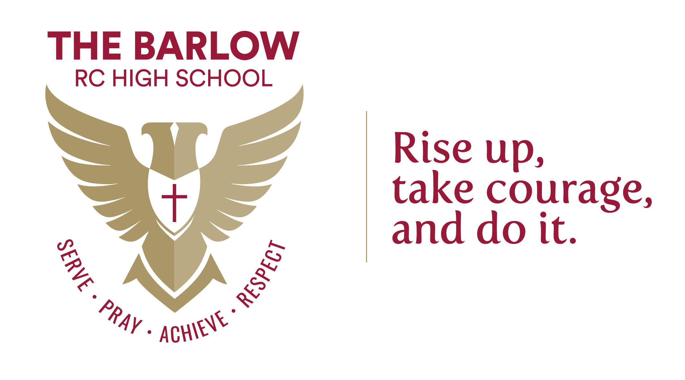
MUSIC
TEACHER

Starting: 1st September 2026
Contract: Full Time, Permanent
Salary: MPR/UPR

An exciting opportunity has arisen for an energetic, creative and ambitious Music Teacher to join our vibrant and forward-thinking school. We are looking for someone who is passionate about music and committed to inspiring pupils across both key stages to develop their musical skills, creativity and confidence, achieving exceptional outcomes. The ability to teach music across a range of styles and ensembles would be an advantage.

This is a fantastic role for someone who brings musical flair, fresh ideas and a genuine love of the subject—whether through performance, composition, music technology, ensemble work, or a combination of musical disciplines.

Our ideal candidate will:
- Be an excellent classroom practitioner committed to high-quality teaching and learning.
- Be passionate about Music, bringing imagination and innovation to the curriculum.
- Possess the ability to inspire, motivate and challenge pupils of all abilities.
- Play an active role in the life of the school and contribute to our wider creative and cultural offer.
- Be driven to secure the very best outcomes for all learners.

In return, we offer:
- A skilled, talented and supportive team of colleagues.
- A comprehensive programme of purposeful, relevant CPD tailored to your professional growth.
- A minimum of 16% PPA for all teachers (ECTs in line with statutory guidance).
- A behaviour culture grounded in high expectations, supported by a centralised behaviour system.
- Regular review of staff workload and a strong commitment to wellbeing.
We warmly welcome applications from both ECTs and experienced teachers.
To apply, please return a completed application form to hr@thebarlowrchigh.co.uk.
Please note: CVs are not accepted.

Closing date: Friday 24th April 2026, 8.00 am
Interview date: Week beginning 27th April 2026

About our School

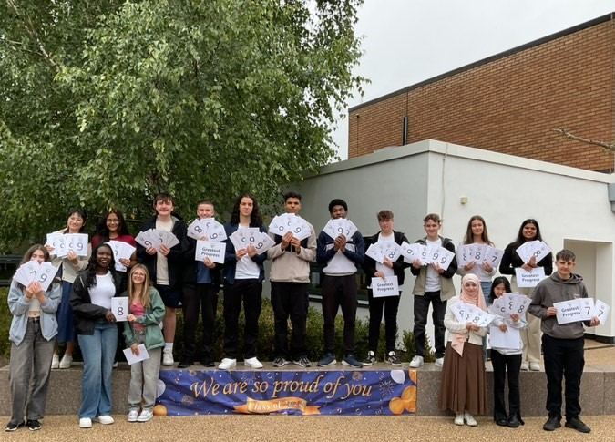
The Barlow is a highly successful, mixed, 11-16 Catholic comprehensive school. In July 2024, Ofsted judged our school to be ‘Good’ in all categories. In May 2025, our school was judged ‘Outstanding’ in all categories in the Catholic Schools Inspection. Our examination results are strong; above national average in most subject areas. We are a diverse and inclusive community, with high standards of pupil behaviour and a calm and purposeful learning environment. The school is located in Didsbury, a popular area of south Manchester, with excellent transport links.

Our school is committed to safeguarding and protecting the wellbeing of children and young people, and expects all staff to share their commitment. An enhanced DBS and social media screening are required for all successful applicants.

Our school is passionate about diversity and treat everyone equally, without compromise. We are committed to providing equality and fairness throughout our recruitment and employment practices and not discriminating on any grounds.




The Barlow RC High School
Parrs Wood Road, Didsbury, Manchester, M20 6BX
www.thebarlowrchigh.co.uk
0161 445 8053
Our school is committed to safeguarding and protecting the wellbeing of children and young people and expects all staff to share their commitment. An enhanced DBS is required for all successful applicants. To comply with our safer recruitment policy, successful candidates are also subject to a social media screening.

The Barlow RC High School
Parrs Wood Road, Didsbury, Manchester, M20 6BX
0161 445 8053
www.thebarlowrchigh.co.uk

