
Mathematics
Curriculum
Leader

Starting: 01 September 2026
Contract: Full Time, Permanent
Salary: MPR/UPR + TLR 1C £14,864
The Governors of The Barlow RC High School are seeking an inspirational and ambitious Mathematics Curriculum Leader who is ready to make a real impact. This is an exciting opportunity for an exceptional maths practitioner with the drive, creativity and strategic vision to take an already strong department to the next stage of its journey—building proudly on the excellent foundations already in place.
You will lead a passionate and experienced team of eight dedicated professionals who are committed to delivering outstanding learning experiences and ensuring every pupil fulfils their potential.
We are looking for someone who:
- Has proven experience of successful middle leadership.
- Is highly organised, proactive and ready to make a difference from day one.
- Is an outstanding classroom practitioner with a deep love of mathematics.
- Can inspire and develop others through strong leadership and innovative practice.
- Thrives on leading whole-school initiatives and driving improvement.
- Can motivate, challenge and engage both pupils and staff.
- Contributes positively to school life and the wider community.
- Has a strong track record of excellent outcomes and the ambition to secure success for every learner.
In return, we offer:
- A talented, hardworking team of colleagues who are passionate about teaching and learning.
- A comprehensive, purposeful CPD programme tailored to support your professional growth and leadership development.
- 25% PPA for all Curriculum Leaders, ensuring you have the time needed to excel.
- A behaviour culture built on high expectations and a centralised system that supports staff.
- A commitment to reducing unnecessary workload and supporting staff wellbeing.
- A friendly, inclusive and highly supportive environment where you can thrive and continue to grow as a leader.
If this sounds like the perfect next step in your career, we’d love to hear from you.
Visit our website at http://www.thebarlowrchigh.co.uk to download an application pack.
Please return completed applications to hr@thebarlowrchigh.co.uk, quoting the post title and your name in the subject line. Please note that CVs will not be accepted. This post is not open to ECTs.

Closing date: Friday 27th March 2026, 7.00am
Interview date: Week beginning 30th March

ABOUT OUR SCHOOL
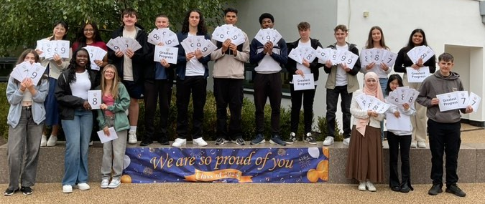
The Barlow is a highly successful, mixed, 11-16 Catholic comprehensive school. In July 2024, Ofsted judged our school to be ‘Good’ in all categories. In May 2025, our school was judged ‘Outstanding’ in all categories in the Catholic Schools Inspection. Our examination results are strong; above national average in most subject areas. We are a diverse and inclusive community, with high standards of pupil behaviour and a calm and purposeful learning environment. The school is located in Didsbury, a popular area of south Manchester, with excellent transport links.

Our school is committed to safeguarding and protecting the wellbeing of children and young people, and expects all staff to share their commitment. An enhanced DBS and social media screening are required for all successful applicants.

Our school is passionate about diversity and treat everyone equally, without compromise. We are committed to providing equality and fairness throughout our recruitment and employment practices and not discriminating on any grounds.



The Barlow RC High School
Parrs Wood Road, Didsbury, Manchester, M20 6BX
www.thebarlowrchigh.co.uk
0161 445 8053

The Barlow RC High School
Parrs Wood Road, Didsbury, Manchester, M20 6BX
www.thebarlowrchigh.co.uk
0161 445 8053
The Barlow RC High School
Parrs Wood Road, Didsbury, Manchester, M20 6BX
www.thebarlowrchigh.co.uk
0161 445 8053

