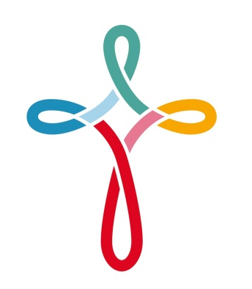
St. Catherine’s R.C. Primary School

Level 3 Teaching Assistant
Required to start September 2026
19.5 hrs per week Tuesday to Thursday
Fixed term contract until August 2027.

We are looking to appoint an enthusiastic and motivated Teaching Assistant who thrives on providing the best possible education for our children and who loves to see them grow and develop both academically and emotionally.
St. Catherine’s is a vibrant Catholic Community in Didsbury which has happy, motivated children and a friendly and dedicated staff team. We would welcome applications from committed teaching assistants who would become fully involved in supporting and promoting the Catholic ethos of our school.

The school is committed to safer recruitment and appointments are made subject to satisfactory references, pre-employment health checks and a successful DBS disclosure. Safeguarding and promoting the welfare and safety of children and young people is an expectation on all staff.

Closing Date: Thursday 25th June
Shortlisting: Friday 26th June
Interviews : w/c 29th June

To request an application form please email admin@st-catherines.manchester.sch.uk

Please return all completed application forms to-

j.hartley@st-catherines.manchester.sch.uk by 9am on 25th June 2026

