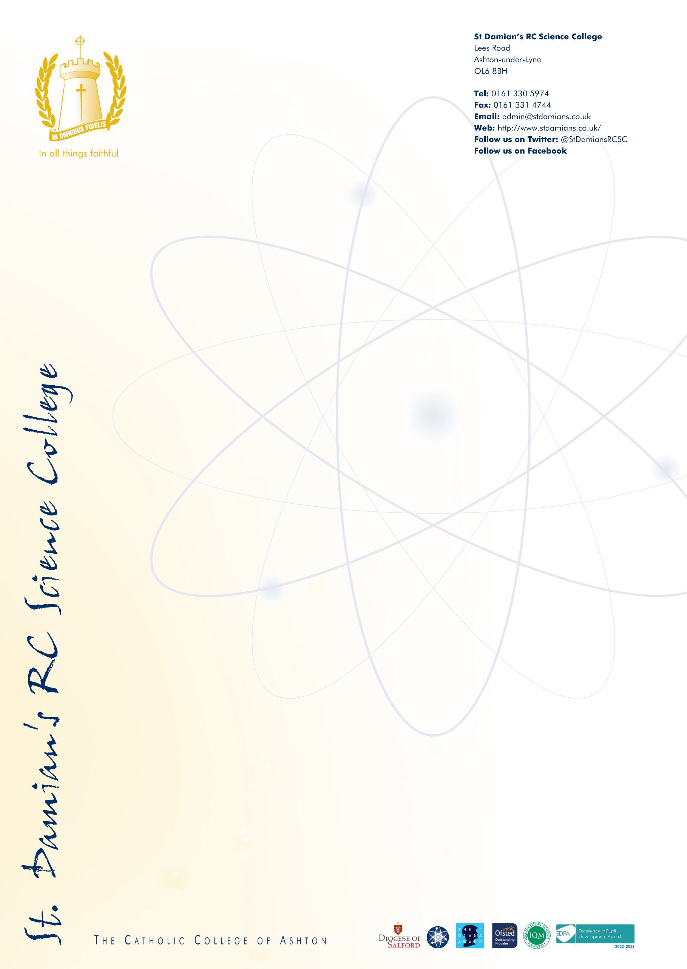
Headteacher St Damian’s RC Science College
Salary: L25 – L34 Required September 2026

St Damian’s RC Science College is a highly regarded and heavily oversubscribed Catholic school, where the safety, wellbeing and dignity of every child are paramount. We are deeply committed to creating a culture in which pupils feel safe, valued and able to flourish academically, spiritually and emotionally.

The Governors are seeking to appoint an inspirational, strategic and values driven Headteacher to lead the College into its next phase of excellence. This is an exciting opportunity for a leader who, builds upon strong foundations and continues to secure excellent outcomes for all pupils and places safeguarding at the heart of school life.

The successful candidate will be a practicing Catholic and passionately committed to exceptional teaching and learning, able to inspire pupils of all abilities and fully supportive of the Catholic ethos of the College. They will work closely with an experienced and dedicated leadership team to ensure that St Damian’s continues to be a highly successful Catholic school, where high expectations combined with excellent pastoral care.

At St Damian’s, safeguarding is integral to our work and underpins all that we do. Our pupils thrive because they are known, heard and protected, and leaders are vigilant in ensuring robust safeguarding systems, a strong commitment to continuous learning and a culture of care. The Headteacher will lead by example, ensuring that safeguarding remains a shared responsibility and a lived value across the whole school community.

Located on the Tameside and Oldham border, St Damian’s is widely recognised for the quality of care it provides for pupils and the professional development opportunities afforded to colleagues. Staff wellbeing is a priority, with a culture built on mutual respect, collaboration and support.

Prospective applicants are welcome to contact Angela Ogden 0161 330 5974 to arrange a visit to learn more about the role and our community.

CES application forms and further details can be downloaded by following the link: https://www.stdamians.co.uk/headteacher

Completed Applications should be returned to the school F.A.O Ms L Dean, Chair of Governors; email vacancies@stdamians.co.uk

Closing Date for Applications: 12 noon, Thursday 14th May 2026
Interviews will take place on Tuesday 19th May and Wednesday 20th May 2026

Safeguarding Declaration:
St Damian’s Roman Catholic Science College is wholly committed to safeguarding and promoting the welfare of children and young people. Safeguarding is a fundamental priority, embedded within leadership practice, governance oversight and daily school life. All staff and leaders are expected to share this commitment and to uphold the highest standards of professional conduct. Any appointment will be subject to rigorous safeguarding checks, including an enhanced DBS disclosure and other pre-employment checks in line with statutory guidance. On-line checks will be carried out for shortlisted candidates.

