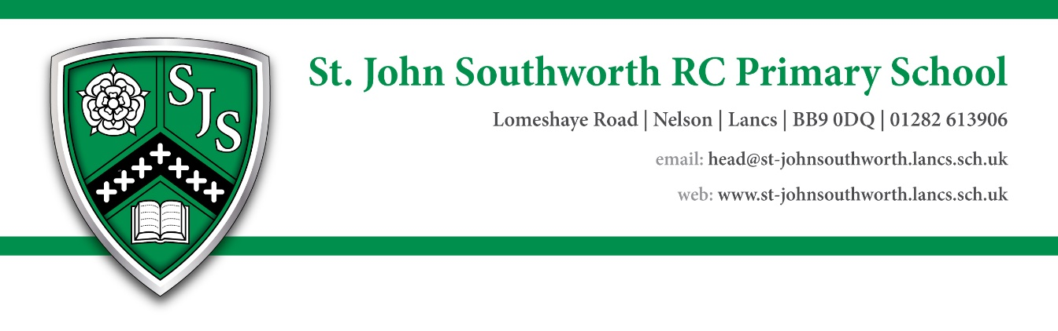

Cleaning Position at St John Southworth RC Primary School Academy

The Governors of St John Southworth RC Primary School wish to appoint a hard-working and enthusiastic cleaner.

Our school is a happy and friendly school that is well thought of in the community.  We are a good school with positive values, a friendly and dedicated team and excellent relationships with pupils and parents are important to us.

Normal core hours worked as below (10 hours weekly):  
Monday to Friday: 3:30 – 5:30pm  
During the school holidays these working times may be changed by mutual agreement to allow for deep cleaning, contractor works and ongoing maintenance or building projects.  
  
  
Please note that in line with Keeping Children Safe in Education 2024, an online search will be carried out as part of our due diligence on shortlisted candidates.

Closing date: Friday 12th July 2024 at noon.

Proposed interview date: 18/07/2024

**We would like you to have:-**

**Essential**

• Experience in cleaning duties and knowledge of best practices in cleaning

• Ability to work under own initiative without supervision

• Aware of the importance of providing a quality service and satisfying the cleaning requirements of the school

• Aware of importance of hygiene in the work place

• Ability to work on your own and to work as part of a team

**Desirable**

• Understanding of Keeping Children Safe in Education and their responsibilities for Safeguarding

• Understanding of Health and Safety regulations as they relate to the operation of cleaning equipment and materials

• Awareness of Control of Substances Hazardous to Health (COSHH)

• Understanding of the School’s ethos and values

• Understanding of school policies and willing and able to work within these

• Has a ‘Can do attitude’

**For an informal discussion please contact:**

Contact Jemma Stuttard (Headteacher) on 01282 613906