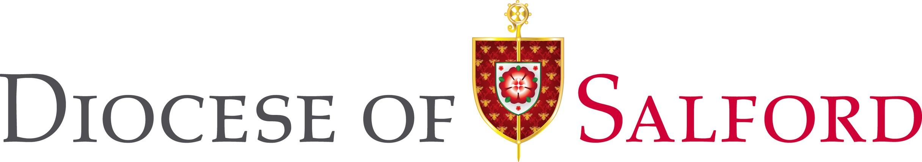

Choral Director
Application Pack August 2026



Contacts for Enquiries
please contact the HR department: Telephone: 0161-817-2203
Email: HR@dioceseofsalford.org.uk


Introduction

The Diocese of Salford is looking to recruit an outstanding Choral Director to help deliver the work of the Salford Schools Singing Programme (SSP) in Diocesan schools.
The programme forms part of the National Schools Singing Programme. It aims to embed a high-quality singing programme within schools across the diocese, through regular whole-class singing sessions and after school choirs.
The programme is now in its fifth year and is led by the experienced lead practitioner and part of the Diocesan Education Department. As well as engaging with over 3,000 children and young people through in-class singing sessions each week, the programme also offers large scale performance opportunities, with recent highlights including a massed ‘Big Sing’ event at The Lowry, Salford Quays, for the launch of the Salford Songbook initiative.
The Choral Director will be an individual who is passionate about the power of music to transform lives and evangelise through singing.

The Diocese

The Roman Catholic Diocese of Salford serves over 100 parishes and 200 schools much of Greater Manchester north of the Mersey and Lancashire including Blackburn and Burnley.

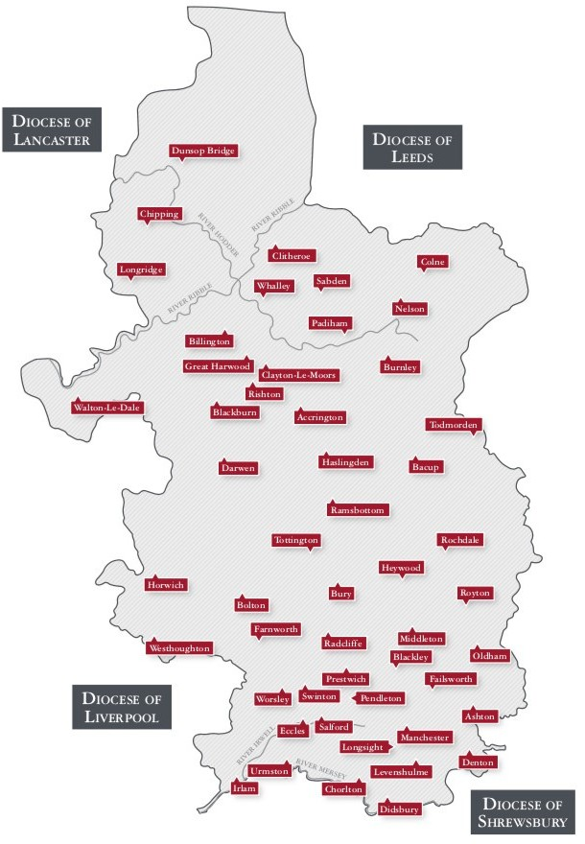

Details
Appointment Type: Part-time – term time, 12-month fixed term contract. (This role is dependent on specific funding)

Working hours: 14 hrs per week, over 40 weeks (term time), flexible working will be required including occasional evening and weekend work. Please note, we may also be interested in hearing from people seeking other work patterns and may have further flexibility.

Location: Cathedral Centre, Ford Street, Salford, M3 6DP. Regular travel throughout the Diocese of Salford will be required (business mileage in line with HMRC guidelines will be payable).

Salary, pension, and benefits: Actual (40 weeks + 5.6 weeks holiday pay) = £9,869 paid in 12 monthly installments. (£28,127 per annum -full time equivalent)
Closing date: 21st September 2026
Interviews: 1st October 2026

What we are looking for
The Choral Director will play a key role in the delivery of the Salford Schools Singing Programme to:
- Deliver outstanding whole-class singing sessions to school children in classroom and assembly settings within the school timetable and in line with the national curriculum
- Plan sessions and provide termly class reports using our high quality resources and templates
- Liaise with headteachers and teaching staff to ensure that pupils are well-equipped to provide music for collective worship in and performances
- Foster links between schools and parishes and work with colleagues to provide progression routes from school sessions into after-school choirs
- Provide CPD to teachers on a local level to up-skill and build confidence in leading singing in the classroom outside of sessions led through the Schools Singing Programme

The Choral Director may have opportunities to collaborate with Salford Cathedral’s Music department, particularly in our choirs for children and young people.

Person Specification

Essential
Education to degree level (or equivalent) in any subject.
Qualification

Experience of teaching

Experience, Knowledge & Skills
class and choral singing to
children.

Ability to play the piano.

Deep knowledge and passion for music.

Good communicator at all levels, both verbally and in writing.

Digitally and ICT confident

Excellent preparation and organisation skills.

Desirable

Experience of performing a wide range of repertoire in school and performance contexts

Essential
Desirable
A clear understanding of safeguarding issues and committed to best practice.
Experience,
Knowledge & Skills (cont.)

Friendly and approachable manner.

Personal Qualities & Characteristics

Understanding the importance of respect for others, equality, and respect for diversity.

The ability to work flexibly to respond to the needs of the key stakeholders.

Able to work effectively, both independently and collaboratively.

A willingness to work within the ethos and values of the Roman Catholic Church and as a parish church.

An inspiring educator with a passion for singing.

Essential
Desirable
This post is subject to a satisfactory Enhanced Disclosure by the Disclosure and Barring Service and barred list checks as this involves working with children.

Other Requirements

All employees of the Diocese are expected to work to promote the safeguarding of vulnerable groups.

Willing to pursue continuing training in all aspects of liturgy and music.

Current valid driving license with access to a vehicle or ability to travel independently across the less accessible diocese.

How to Apply

Closing date for applications: 21st September 2026
Interviews to be held: 1st October 2026
Please note, interviews will take place in a school so with regret, we are unable to offer any flexibility with the interview dates.

For further information or to apply, please visit our website: www.dioceseofsalford.org.uk/news/vacancies

If you have any queries about the role or require any reasonable adjustments to access the recruitment process, please contact HR@dioceseofsalford.org.uk

Salford Roman Catholic Diocesan Trustees Registered Charity Registered Charity No. 250037

