

Cathedral Business Manager
Application Pack September 2026

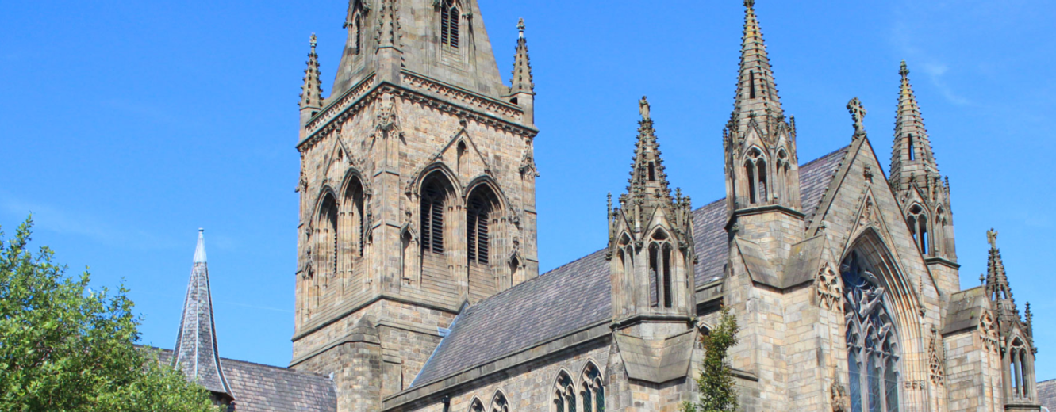

Contacts for Enquiries
Please contact the HR department:
Telephone: 0161-817-2203
Email: HR@dioceseofsalford.org.uk


Introduction

Following a major restoration and renewal programme, the Cathedral Church of St John the Evangelist stands at a pivotal moment in its history. As the Mother Church of the Roman Catholic Diocese of Salford, it has been at the centre of worship, mission and diocesan life for more than 175 years. The recent project has breathed new life into this historic building, preserving its heritage while strengthening its role in the community for generations to come.

Alongside preserving its rich heritage, the Cathedral has been equipped for the future through enhanced facilities, greater flexibility, improved accessibility and a strong commitment to sustainability. These developments ensure that the Cathedral can continue to serve as a place of worship, welcome, community engagement and cultural significance.

The Cathedral Business Manager is a new role and will play a key role in helping to realise this vision. The successful candidate will provide operational leadership to ensure the Cathedral's resources, facilities and services are managed effectively and sustainably, supporting its mission and enabling it to flourish in the years ahead. Reporting to and working closely with the Cathedral Dean and supported by our Diocesan Curia, they will take responsibility for operations, facilities, administration, finance and income generation.

This pivotal role includes working in collaboration with the Diocesan Curia to develop new commercial and funding opportunities and managing budgets effectively. This is a challenging context requiring resilience and tenacity as well as change management skills.

Canon Michael Jones, Cathedral Dean

The Diocese

The Roman Catholic Diocese of Salford serves over 100 parishes and 200 schools much of Greater Manchester north of the Mersey and Lancashire including Blackburn and Burnley.

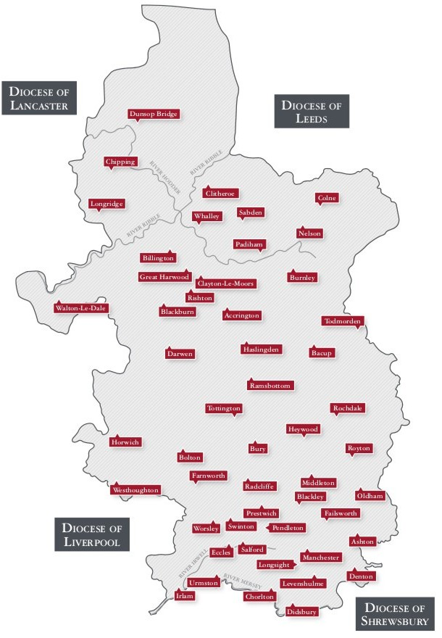

Details
Appointment Type: Full time, 35 hours per week, usually Monday to Friday but with occasional, planned work out of hours.

Location: The successful candidate will need to be based at The Cathedral Church of St John the Evangelist, Chapel Street, Salford M3 5LL.

Salary, pension, and benefits: £39,529 - £45,360 (based on skills and competencies)
25 days annual leave
5 Diocesan closure days
Statutory holidays
People’s Pension Scheme
Employee Assistance Programme
Free, secure parking

Closing date: Midday 22nd September 2026
Interview date: Interviews 29th September 2026

What we are looking for
Main Purpose of the Role
The Cathedral Business Manager, reporting to the Cathedral Dean, is responsible for the effective management of the Cathedral's operational and business functions, ensuring that the Cathedral is professionally managed, financially sustainable and fully compliant with all statutory and diocesan requirements

The postholder, reporting to and working closely with the Cathedral Dean, will oversee the Cathedral's physical, financial, and personnel resources, supporting the Cathedral's role as the parish church for the local catholic community and the mother church of the Diocese of Salford.
Operations and Administration
- Ensure the smooth day-to-day operation of the Cathedral.
- Develop and maintain effective operational procedures.
- Coordinate operational arrangements for liturgical celebrations, diocesan and other major events.
- Support Cathedral staff and volunteers in delivering excellent hospitality and visitor experience.
- Manage day-to-day parish office operations, ensuring a welcoming environment for all visitors.
- Oversee parish correspondence, maintain accurate church records (e.g., baptisms, weddings, parish census). Supervise administrative support for the sacramental programme and other parish courses and parish groups.
- Ensure secure data management in compliance with GDPR / diocesan policies.
- Manage, monitor and respond when required to general parish enquiries (in-person, phone, email and via the website) in a timely manner.
- Maintain a complex Cathedral calendar, integrating external bookings alongside the regular liturgical, pastoral and weekly parish events schedule.
- Manage the compilation, production, and distribution of the weekly newsletter, parish emails, and website updates.

Finance and Stewardship
- Manage the Cathedral's financial administration, ensuring sound stewardship of the Cathedral's resources.
- Monitor income and expenditure and provide regular financial reports to the Cathedral Dean to support informed decision-making.
- Collaborate with the Diocese Finance Department.
- Develop and monitor the annual parish budget in close collaboration with the Cathedral Dean.
- Ensure effective financial controls and compliance with diocesan financial regulations and charity requirements. Manage procurement processes, contracts and service level agreements, ensuring value for money. Oversee purchasing systems, supplier relationships and payment processes.

- Manage the counting and secure banking of weekly offertory collections and donations, maintaining records for Gift Aid and diocesan audits.
- In collaboration with the diocesan fundraising team, research, plan, and coordinate fundraising initiatives and special appeals to support parish ministries and capital projects.

Income Generation and Commercial Development
- Working closely with the Dean to ensure that all events and activities support the Cathedral's mission and long-term sustainability.
- Develop and implement strategies to increase unrestricted income.
- Maximise revenue from guided tours, retail, and donations.
- Develop opportunities for concerts, exhibitions, lectures, conferences and cultural events consistent with the Cathedral's liturgical life and mission.
- Working with the Diocesan Fundraising team, identify grant funding opportunities and support applications for heritage, conservation and community projects.
- Working closely with the Dean of the Cathedral and other members of the Cathedral Clergy, along with the Diocesan Fundraising Team develop relationships with benefactors, sponsors and local businesses.
- Monitor performance and prepare reports on income generation.

People
- Line manage the small operational and administrative staff team.
- Conduct regular performance appraisals, manage staff development, and oversee day-to-day HR matters (sickness, annual leave) in line with diocesan HR policies and in close collaboration with the Cathedral Dean.
- Build productive relationships with clergy, volunteers, diocesan departments, and external partners.
- In collaboration with the Cathedral Volunteer Coordinator, manage and develop the scope of volunteering in the Cathedral ensuring compliance with safeguarding and safer recruitment.
- Promote a culture of professionalism, hospitality, stewardship and service. Support organisational change and continuous improvement.
- Ensure compliance with employment legislation and diocesan HR policies. Foster a positive working environment rooted in Catholic values.

Buildings, Estates and Health & Safety
- Supported by the Diocesan Property Department, and in collaboration with the Cathedral’s facilities team, manage the maintenance and conservation of the Cathedral Church and Cathedral House.
- Ensure compliance with health and safety legislation.
- Oversee planned preventative maintenance programmes.
- Ensure fire safety, security, emergency planning and risk assessments are maintained.
- Manage facilities contracts and supervise contractors working on site.

Compliance
- Ensure compliance with charity law, safeguarding requirements, diocesan policies and other statutory obligations.
- Maintain Cathedral policies and compliance registers.
- Prepare reports for meetings and relevant cathedral committees.

The postholder will be expected to undertake any other reasonable tasks and duties as required.

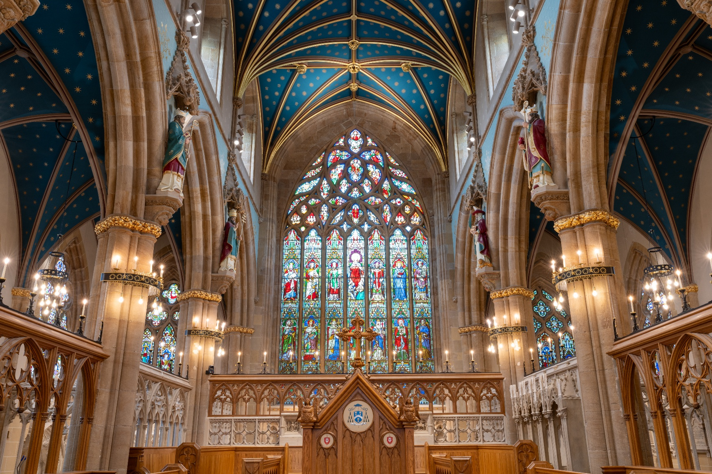

Person Specification

 | Essential | Desirable
Qualifications and training: | - A good standard of education GCSEs or equivalent, including English & Maths  - Level 4 AAT/ diploma in school business management or equivalent professional qualification / experience.  - Evidence of continuous professional and personal development (CPD) | - Experience within the Catholic Church, wider Church, faith, charity, education or heritage sector.  - Experience of developing commercial income and fundraising initiatives.
Experience: | - Significant skills developed in operations, finance or business management.  - Experience of estates, facilities and health and safety management. | - Knowledge of heritage conservation and visitor management.  Understanding of the mission, governance and pastoral life of a Catholic Cathedral
Knowledge, skills, and abilities: | - Knowledge of regulatory compliance.  - Proven leadership and people management experience.  - Excellent organisational, communication and problem-solving skills.  - Ability to balance operational priorities with strategic objectives.  - Good IT skills (MS Office, etc.)
Personal qualities: | The successful candidate will have:  - High expectations of themselves and the ability to set and maintain professional standards for others.  - Reliable with the ability to work as both part of a team and independently.  - High levels of drive and integrity.  - Strong team player
Other requirements: | - This post is subject to a Disclosure by the Disclosure and Barring Service.  - All employees of the Diocese are expected to work to promote the safeguarding of vulnerable groups.  - An understanding that the Diocese of Salford is a faith-based religious organisation and the ability to work with sympathy towards and respect for the values and ideals of the Church.  - Willing to undergo further training and development as required.  - Able to represent the high standards expected of all staff with a clean and smart appearance.
The above description is not intended to be an exhaustive list but to indicate the main responsibilities of the post. It may be amended from time to time, after consultation with the post holder.

How to Apply

Closing date for applications: 22nd September 2026 (midday)
Interviews to be held: 29th September 2026

For further information or an application form, please visit our website: www.dioceseofsalford.org.uk/news/vacancies

If you have any queries about the role, please contact HR@dioceseofsalford.org.uk

If you require any reasonable adjustments to access this recruitment process, please contact HR@dioceseofsalford.org.uk

Salford Roman Catholic Diocesan Trustees Registered Charity Registered Charity No. 250037

