

Teacher of Business & Computer Studies
Starting: | 1st September 2026
Contract: | Full Time, Permanent
Salary: | MPR/UPR
An exciting opportunity has arisen for a hardworking, passionate and committed Business and Computing teacher to join our school from September 2026. You will need to be able to teach across both key stages and the full range of prior attainment and be committed to delivering excellent outcomes for pupils.

Our ideal candidate will:
- Be an excellent teacher who is committed to delivering high-quality teaching and learning.
- Be passionate about your subject and its delivery.
- Possess the ability to inspire, challenge and motivate pupils.
- Play an active role in the school and the wider community.
- Be driven to achieve the best outcomes for all pupils.

In return, we will offer you:
- A skilled, talented team of colleagues to work alongside.
- A comprehensive programme of purposeful, relevant continued professional development that is shaped by your needs.
- Minimum 16% PPA for all teachers. (ECT in line with statutory guidance).
- Focus on high expectations for pupils with a centralised behaviour system.
- Regular review of staff workload in order to support staff wellbeing.

We warmly welcome applications from both ECTs and experienced teachers. If you would like a conversation with a member of the team then please contact us at hr@thebarlowrchigh.co.uk

Closing date: Friday 22nd May 2026, 8.00am (we reserve the right to close this vacancy earlier if a suitable candidate is interviewed and appointed)
Interview date: Suitable candidates will be interviewed on application

About our School

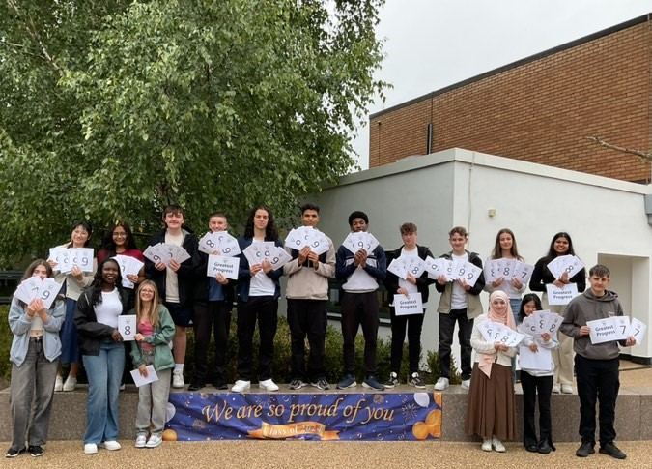
The Barlow is a highly successful, mixed, 11-16 Catholic comprehensive school. In July 2024, Ofsted judged our school to be ‘Good’ in all categories. In May 2025, our school was judged ‘Outstanding’ in all categories in the Catholic Schools Inspection. Our examination results are strong; above national average in most subject areas. We are a diverse and inclusive community, with high standards of pupil behaviour and a calm and purposeful learning environment. The school is located in Didsbury, a popular area of south Manchester, with excellent transport links.

Our school is committed to safeguarding and protecting the wellbeing of children and young people, and expects all staff to share their commitment. An enhanced DBS and social media screening are required for all successful applicants.

Our school is passionate about diversity and treat everyone equally, without compromise. We are committed to providing equality and fairness throughout our recruitment and employment practices and not discriminating on any grounds.





The Barlow RC High School
Parrs Wood Road, Didsbury, Manchester, M20 6BX
www.thebarlowrchigh.co.uk
0161 445 8053

