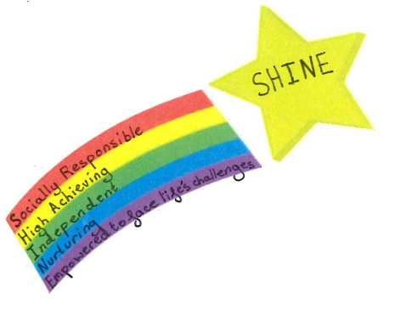
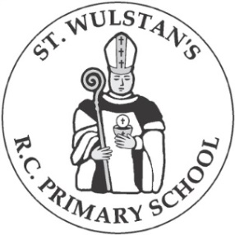

St. Wulstan’s R.C. Primary School
Rushton Street, Great Harwood, BB6 7JQ Tel: 01254 884533
head@st-wulstans-greatharwood.lancs.sch.uk bursar@st-wulstans-greatharwood.lancs.sch.uk
www.stwulstans.co.uk
Headteacher: Miss F Hadfield
Dear Applicant

Welcome to St. Wulstan’s!

We are seeking a dedicated and experienced teacher as our new Assistant Head (L1 – L6) to join our dynamic team and contribute to the continued success of our school.
Our most recent positive Ofsted inspection stated that “St. Wulstan’s Catholic Primary School is a vibrant and nurturing place to learn. Pupils are proud of their school. Leaders are ambitious for all pupils to achieve highly. Many parents and carers said that staff go out of their way to support them and their children.”
The Assistant Headteacher position is a crucial one, as you will be responsible for supporting the school's strategic vision, leading initiatives, and ensuring the highest standards of teaching and learning.
Our school is a warm and inclusive community, where every child is encouraged to reach their full potential. As Assistant Headteacher, you will have the opportunity to contribute to our continued success and help shape the bright futures of our pupils.

Visits to our school are very welcome by appointment; just telephone the school office to arrange a mutually convenient time and we will look forward to showing you around.

If you are ready for a new and exciting challenge and you would like to join us on the next stage of our journey, then we would love to hear from you!

Thank you in advance for showing an interest in this position and our school.

Closing date for applications: 12noon, Thursday 5th February 2026
Shortlisting of applications: Thursday 12th February 2026
Interviews: w/b 2nd March 2026

Yours sincerely

Miss F Hadfield Mrs. S Doughty
Headteacher Chair of Governors

