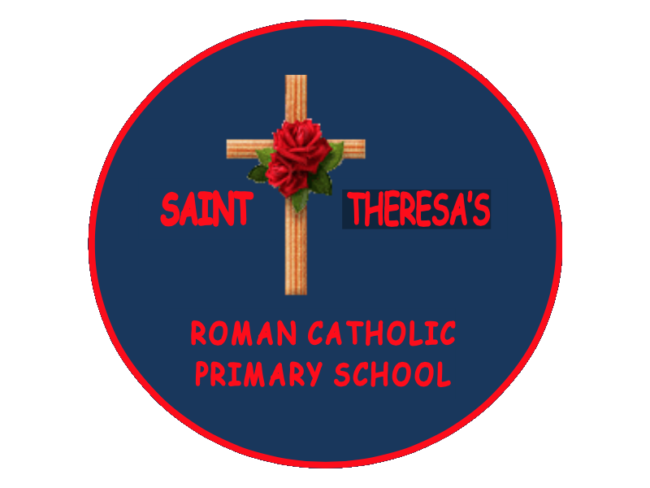
St Theresa’s R.C Primary School
Whetstone Hill Road
Derker
Oldham,
Lancashire
OL1 4NA
Tel : 0161 770 3173

“Walking in God’s Way, we Believe, Achieve and Succeed.”
Headteacher: Mrs L. McCombe

After School Club Playleader
Part time. Term time. Temporary (until 19th July 2025)
10 hours per week
Level 3

Required from 1st September 2024
NOR: 213

The Headteacher and Governors of St Theresa’s R.C. Primary School are seeking to appoint an ‘After School’ Club Playleader to ensure the care and well-being of pupils.

We are a warm, welcoming school dedicated to achieving the best academic and pastoral outcomes for all our children. Our committed staff team work extremely well together providing the best for our children, parents/ carers and community.

We are looking for someone who:

• Will make after school clubs exciting, memorable and enjoyable for our children.
• Has willingness to work as part of a team.
• Will be a good role model
• Has a caring and positive attitude and the ability to respond to a variety of situations.
• Is self-motivated and reliable.
• Is committed to equal opportunities.
• Will respond to the practical needs of children where there is an identified special educational need.
• Will provide general care and welfare by responding appropriately to the social, emotional and physical needs of pupils.
• Will assist in maintaining a healthy, safe and secure environment and act in accordance with all of the School’s policies and procedures.

Our school has & can offer:

- Happy, enthusiastic children who enjoy coming to school to learn.
- A highly motivated, friendly and caring staff team.
- •A staff team who are committed to the further development of our school.
- A supportive Governing Body and Leadership team.

Visits to the school are warmly welcomed, please contact school to arrange.
Applicants must apply using a CES application form, which can be obtained by contacting the school directly on:
info@sttheresas.oldham.sch.uk or linda.mccombe@sttheresas.oldham.sch.uk.
Copies are also available on the school website at:
www.sttheresas.oldham.sch.uk

All applications should be addressed to the Headteacher and sent to the school before the closing date.

Successful applicants will be subject to an enhanced DBS check.

Closing date: Friday 5th July 2024
Shortlisting: Friday 5th July 2024
Interviews: Monday 8th July 2024

